GENETIC INFORMATION

Structure of DNA

The nucleus is the control centre of our cells and it contains all of the genetic information of an individual.

Tightly-coiled, thread-like bodies called chromosomes contain this information.

Chromosomes are only visible when a cell is undergoing cell division.

Each chromosome is made up of genetic material called deoxyribonucleic acid (DNA).

The DNA molecule is a double helix, a twisted ladder with “rungs” made up of four bases called nucleotides - adenine (A), guanine (G), thymine (T) and cytosine (C).

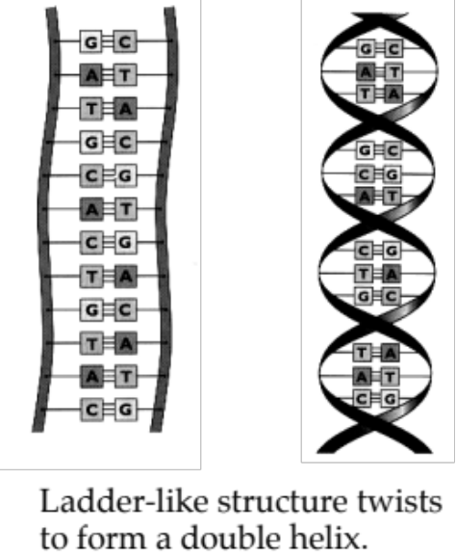

These occur in pairs - A and T, G and C.

The order of these bases and their combinations determines the genes found on the chromosome.

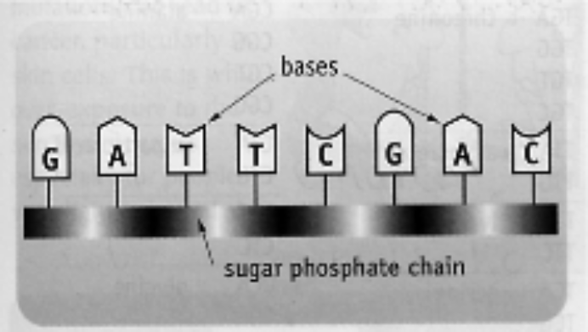

Genetic Code

DNA provides the code for cells to produce proteins that are made up of amino acids. The number of amino acids in a protein can vary from 50 to 50, 000 or more. It is the DNA code that determines an organism's characteristics.

The bases along the DNA strand are arranged in triplet codes. Each triplet code represents one type of amino acid.

e.g. AGA is for serine.
CCA is for glycine.
Some amino acids have more than one triplet code.

e.g. ATA, ATG is for tyrosine.

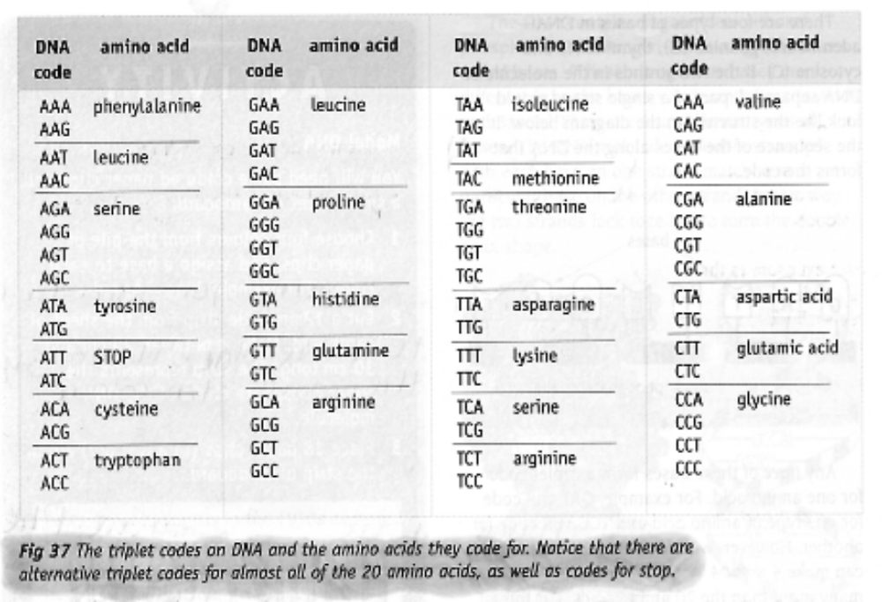

Mutations

Mutations occur in organisms due to alterations in the number or structure of chromosomes
(e.g. Down syndrome), or alterations to genes.

Some mutations are detrimental to an organism, often causing death.

e.g. Mexican hairless dogs are born dead if the "hair" gene is present.

Other mutations are helpful.

e.g. Seedless grapes and oranges.

Mutations occur naturally (about 1 in 1 million sex cells have a mutation), but the rate can be increased as follows.

• Exposure to radiation from X-rays and nuclear materials.
• Exposure to chemicals such as pesticides and those in cigarettes.
• UV radiation in sunlight.

How do mutations change characteristics?

Assume a triplet sequence is as follows.

AAT CAA CCT TCA
(leucine) (valine) (glycine) (serine)

If the second triplet is changed to CCT, then the amino acid formed is glycine rather than valine.

Hence the protein produced is quite different.

Number of Chromosomes

One chromosome can contain thousands of genes.

There is a characteristic number of chromosomes found in a given plant or animal species.

For humans, our normal number is 46 chromosomes (23 pairs) - this is called the diploid number.

All body cells (except the reproductive cells) contain the diploid number of chromosomes.

Reproductive cells have half the normal number (23 chromosomes) - called the haploid number.

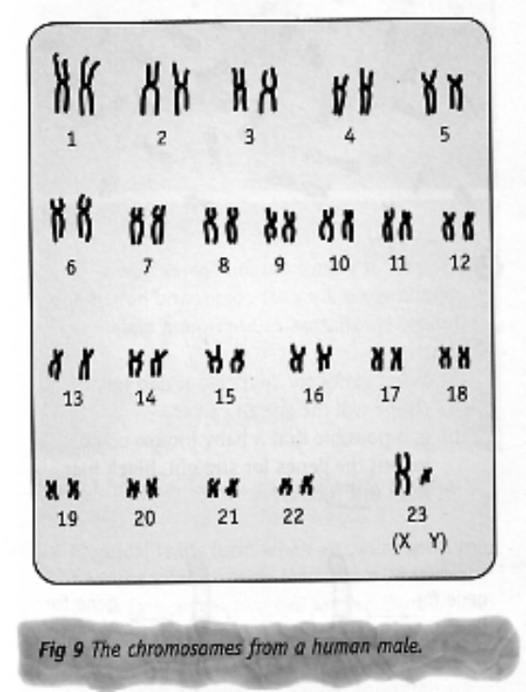
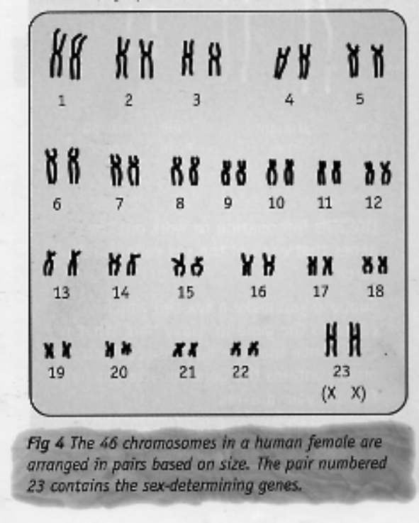

Chromosomes occur in pairs - one from the father, one from the mother. Each chromosome in the pair contains the same sets of genes controlling the same characteristics.

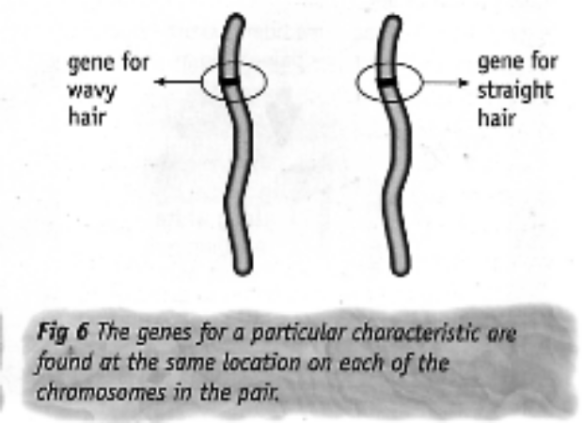

Another pair of chromosomes will have a different set of genes controlling other characteristics.

Mechanism Of Inheritance

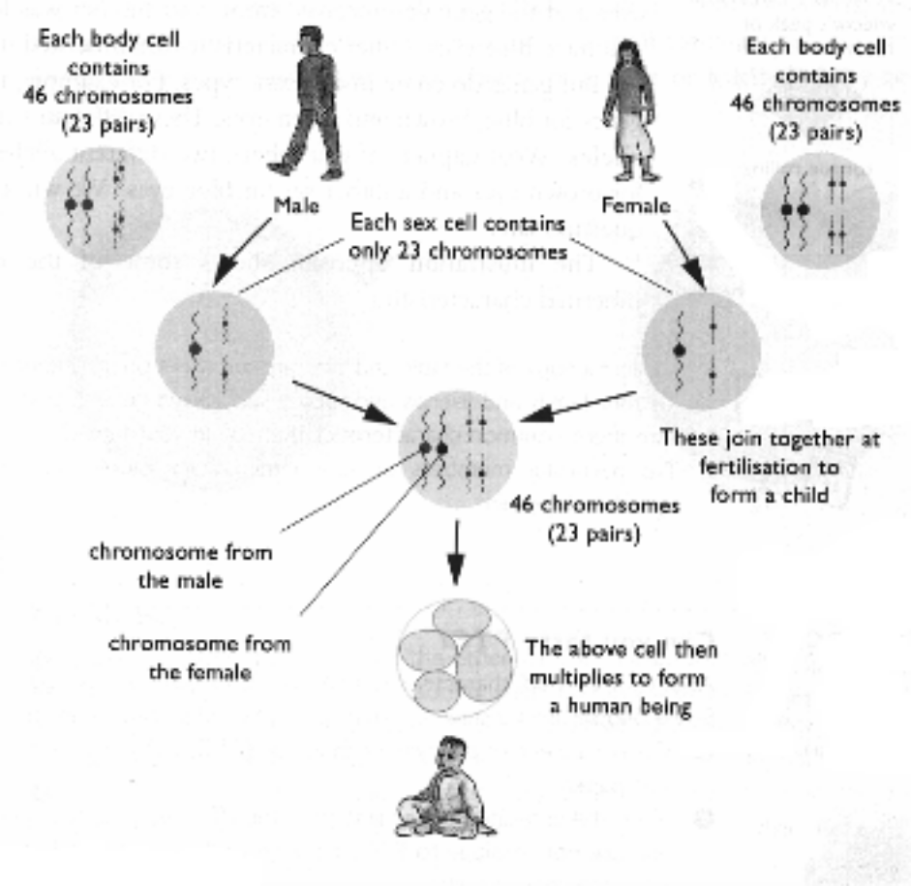
The reproductive cells (called gametes) from the mother and father contain 23 chromosomes each.

Upon fertilisation occurring, a single cell (called a zygote) is formed with the diploid number of chromosomes - 46.

The zygote then undergoes many cell divisions to form an embryo (first 2-3 months), then a foetus (3 months till birth).

The male gamete is a sperm (pollen in plants).

The female gamete is an egg or ovum.

